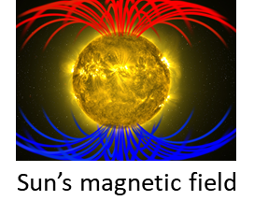[**VISUAL PHYSICS ONLINE**](http://www.physics.usyd.edu.au/teach_res/hsp/sp/spHome.htm)

**MODULE 4.2**

**MAGNETISM**

**ELECTRIC CURRENTS AND MAGNETISIM**

When electric charges are in motion they exert forces on each other that can’t be explained by Coulomb’s law. If two parallel current carrying conductors are near each other they attract each other when the currents are in the same direction and repel each other when the currents are in opposite directions. Such forces are called **magnetic forces**.

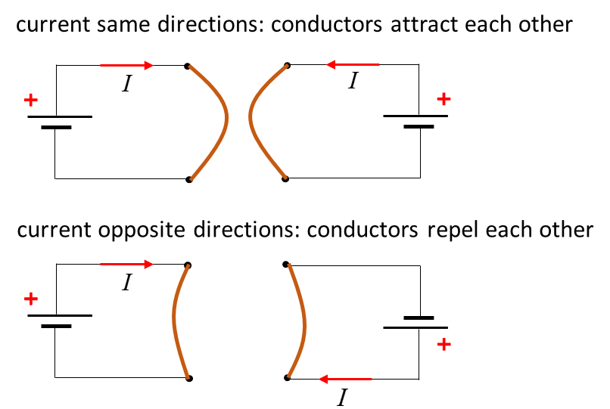

Hans Oersted (1777 – 1815) placed a wire near a compass needle and switch on the current. When the wire was parallel to the compass needle, the compass needle was deflected by the current. When the wire was perpendicular to the compass needle, there was no deflection when the current was switched on. He made two conclusions: (1) the electric current somehow exerts a twisting force on the magnet near it and (2) the magnitude of the force depends upon the relative orientation of the current and the magnet.

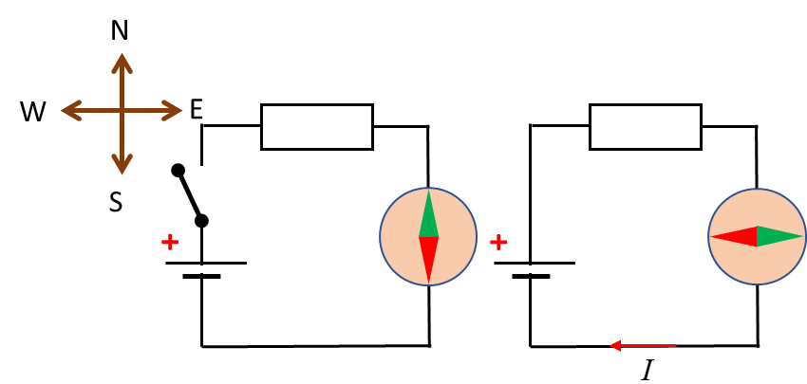

A current (moving charges) through a wire alters the properties of space near it such that a piece of iron will experience a force. Hence, **surrounding a wire carrying a current is a magnetic field**. It is the interaction of the magnetic field and the iron that leads to the force, rather than the current and iron acting upon each other.

The magnetic field surrounding a straight conductor carrying a current  can be visualized as a series of circles. The closer the lines are together, the stronger the magnetic field. A compass placed near the wire will align itself with the field lines. The direction of the magnetic field is determined by the **right-hand screw rule**. Using the right hand: the direction of the thumb represents the current (direction in which positive charges would move) and the curl of the fingers represents the direction of the magnetic field as shown in figure 1. The magnetic field strength is given by the vector quantity where  stands for the **B-field** or **magnetic induction** or **magnetic flux density**. The S.I. unit for the B-field is the **tesla** [T].



Fig. 1. The right-hand screw rule is used to determine the direction of the magnetic field produced by moving charges.

The B-field surrounding a **long straight conductor** carrying a current at a distance  from the conductor is given by equation 1 and as shown in figure 2.

(1)  = 4*π*× 10-7 T.m.A-1

where is a constant called the **permeability of free space**.



Fig. 2. B-field surrounding long straight conductor carrying a current.

A **circular loop conductor** carrying a current produces a magnetic field like a bar magnet as shown in figure 3.

Fig. 3. Magnet field due to a current loop. The direction of the B-field is given by the right-hand screw rule.

A **solenoid** is a conductor wound into a long set of coils



Solenoids are often used as electromagnets where a ferromagnetic substance placed inside the coils greatly increases the strength of the magnetic field. Figure 4 shows the magnetic field patters for an air-filled solenoid and when a rod of ferromagnetic material is placed inside the coils.



Fig. 4. Magnetic field patterns for a solenoid (air and ferromagnetic cores).

The magnetic field of a solenoid is like that of a bar magnet as shown in figure 5.



Fig. 5. Magnetic field patterns for a bar magnet and solenoid.

For a long solenoid, with closely packed coils, the magnetic field within the solenoid and for the entire cross-section is nearly uniform and parallel to the solenoid axis. For an air filled long solenoid carrying a current  of length  and  number of loops, the magnetic field  inside the solenoid is given by equation 2

(2)  **magnetic field inside a solenoid**

We can define *n* as the number of loops per unit length as



and the magnitude of the magnetic field can be expressed as

(3) 

The **direction** of the magnetic field inside the solenoid is determined by the right-hand screw.

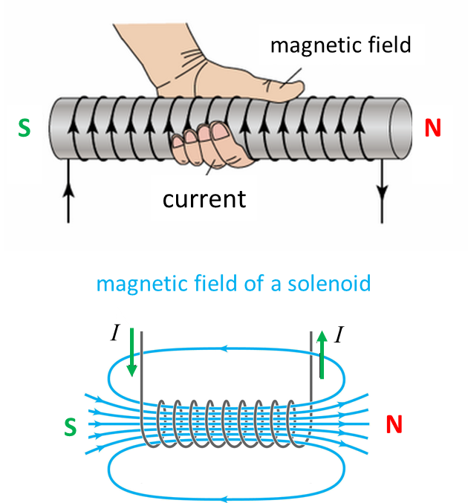

The insertion of a ferromagnetic material into the core of the solenoid can increases the magnetic field significantly. With an ferromagnetic core, the magnitude of the magnetic field is given by

(4) 

where  is called the **magnetic permeability** and is the **relative magnetic permeability** .

The values for the relative permeability  are not constants for ferromagnetic materials but their values depend upon the magnetization history of the material. For iron core, the relative permeability could be in the order of 5000, so one can achieve very high magnetic fields with solenoids with ferromagnetic cores.

|  |
| --- |
| **Example**  A thin 100 mm long solenoid is used as electromagnetic switch.  Explain how the solenoid can be used as switch?  What is the magnetic field near the centre of the solenoid when the current through the coils is 2.00 A and the coil has a total of 400 turns. An iron rod is inserted into the solenoid and the magnetic field was measured to be 12.0 T. What is the relative permeability of the iron rod? By what factor has the magnetic field been increased by using the iron core?  **Solution**  When a current passes through the solenoid, it can act as an electromagnet to attract a magnetic material and hence close a switch. When the current is stopped, the solenoid is no longer an electromagnet and the magnetic material of the switch is no longer attracted to the electromagnet and the switch will then be opened.    Magnetic field without iron core    Magnetic field with iron core |

[VISUAL PHYSICS ONLINE](http://www.physics.usyd.edu.au/teach_res/hsp/sp/spHome.htm)

If you have any feedback, comments, suggestions or corrections please email Ian Cooper

ian.cooper@sydney.edu.au

Ian Cooper School of Physics University of Sydney